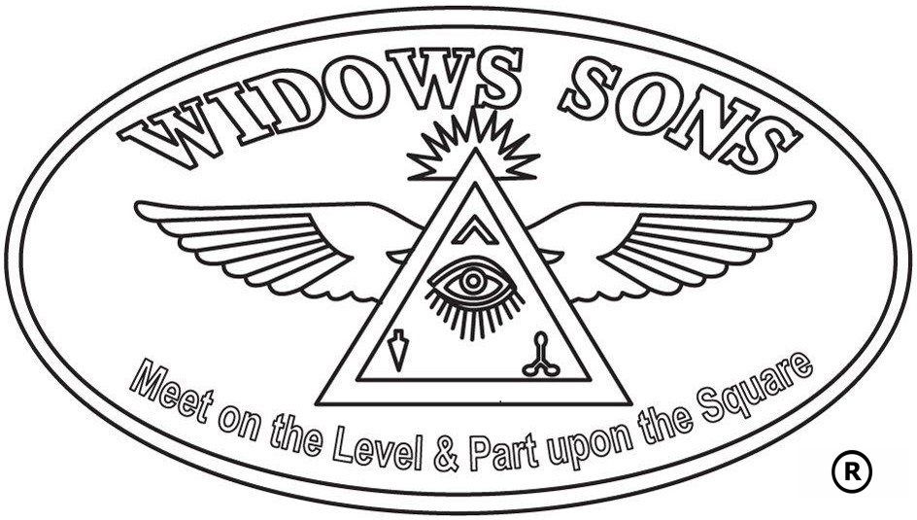
WIDOWS SONS MASONIC RIDERS ASSOCIATION
TRADEMARK LICENSE HOLDERS

APPLICATION FORM

DATE | / /

WIDOWS SONS NAME
LEGAL BUSINESS NAME
EIN # |  |  |  | MASONIC RIDERS ASSOCIATION |  |  | YES NO
GRAND LODGE JURISDICTION
GRAND LODGE RECOGNITION/APPROVED |  |  |  |  |  | YES NO
NUMBER OF MEMBERS [with dues cards under the Grand Lodge listed above]
NUMBER OF MEMBERS [with dues cards under a different Grand Lodge]

NAME OF APPLICANT |  | EMAIL:
TITLE/POSITION |  | PHONE:

ADDRESS

CITY |  | STATE |  | POSTAL CODE

MAIL TO:
WIDOWS SONS LOUISIANA TRADEMARK BOARD
427 NORTH THREAD STREET
SUITE 134
COVINGTON, LOUISIANA 70433

INCLUDE:
CHECK FOR $50.00 MADE OUT TO WIDOWS SONS LOUISIANA

I certify that the information I have given on this form is true and correct to the best of my knowledge.

Signed: _____________________________________ Date: _________________

